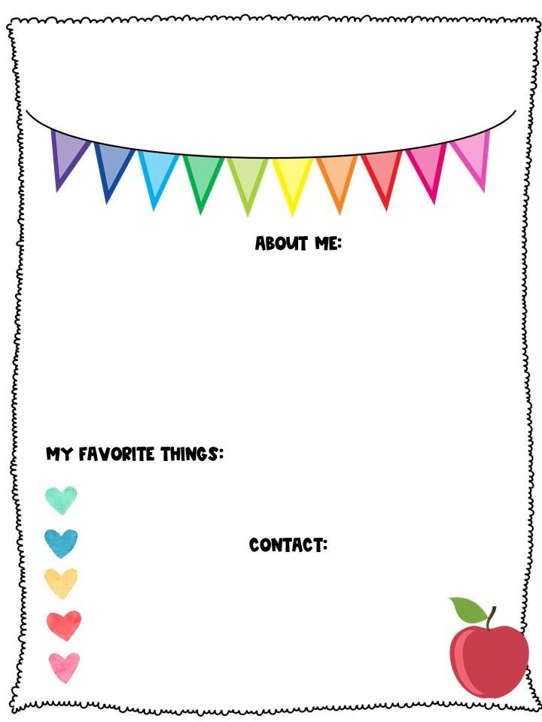

Insert photo here

Hello Bee Family!

I am super excited about

my big move to Wheeless Road Elementary.

I am also excited about the

skills your child will

accomplish this school year.

I am originally from

Charleston, SC and a

former military spouse. I

am a mother of

two,

and

have seven beautiful

grandchildren.

**School:**

(706)796-4985

**Email:** [gistrh@boe.Richmond.k12.ga.us](mailto:gistrh@boe.Richmond.k12.ga.us)

**Add Me on Dojo:**

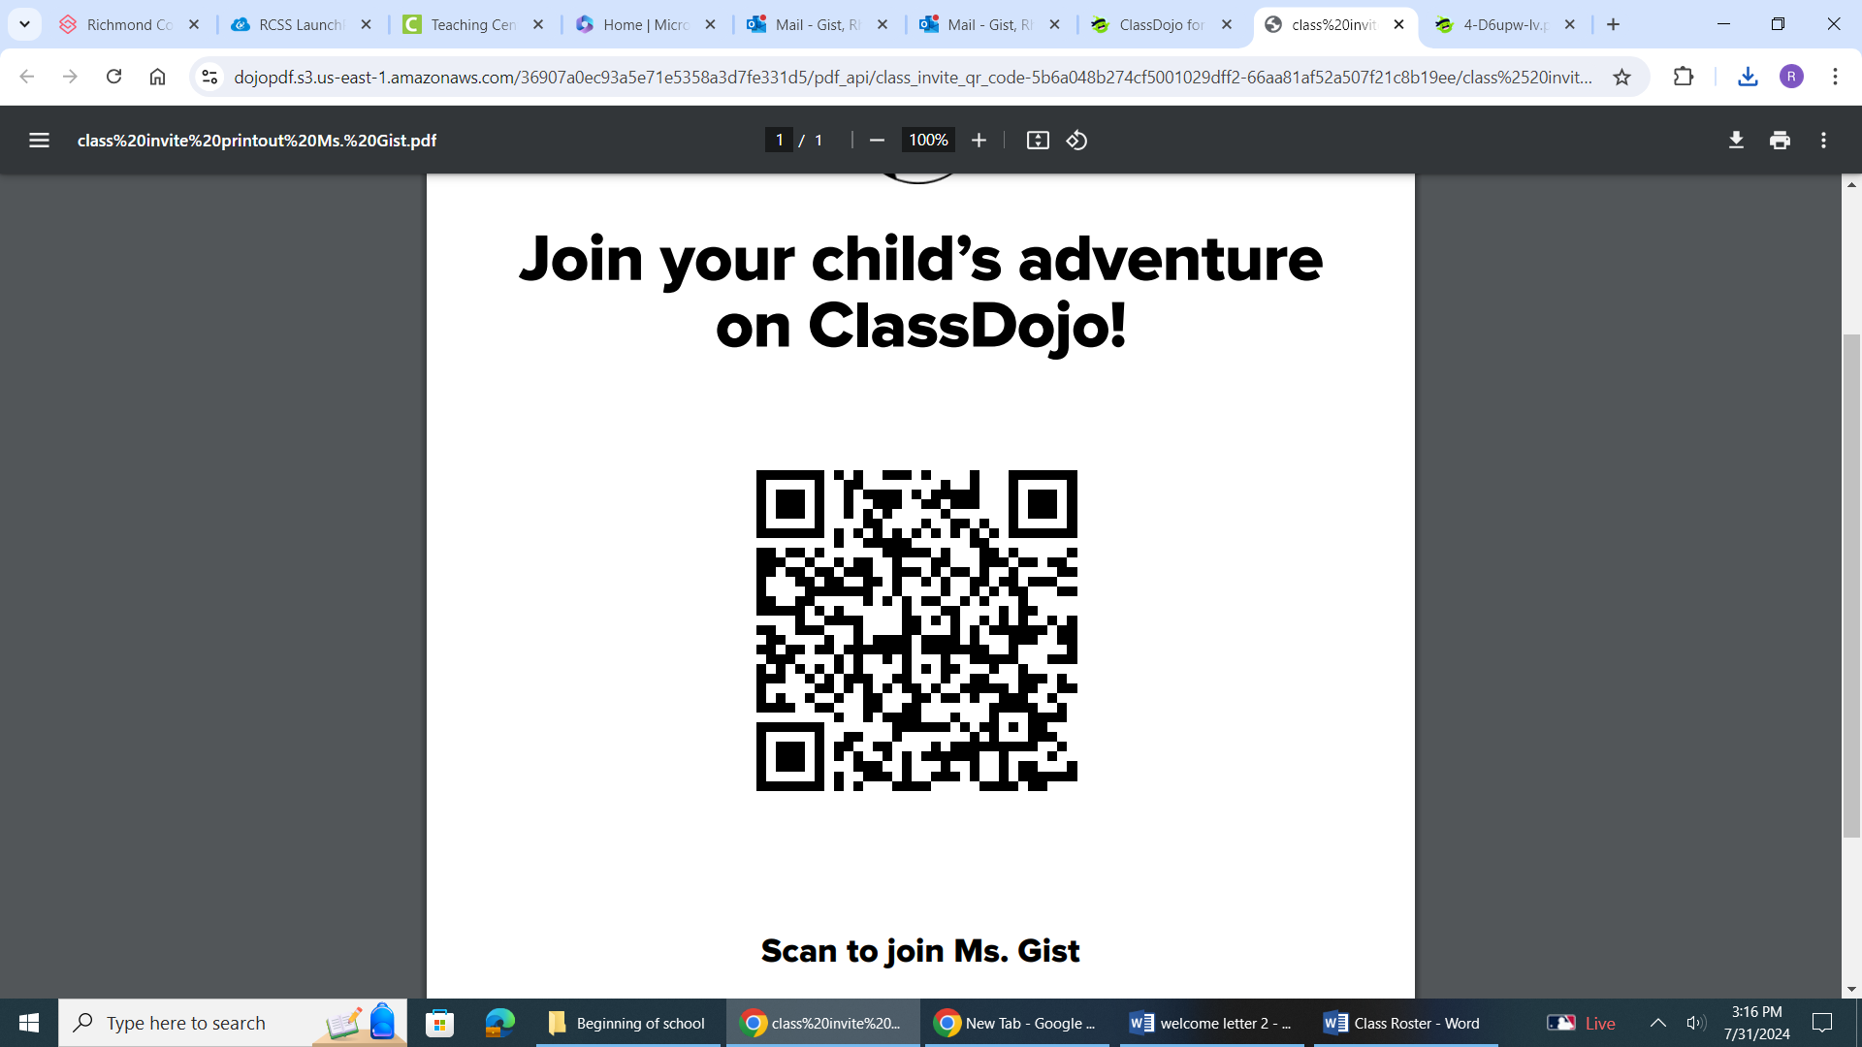

Dallas Cowboys

The colors navy and

brown

Payday candy bars

Pepsi and

Ginger Ale

Shopping, Traveling and

spending time with family

**Welcome to 5th Grade**

Meet

Ms.Gist

